Cluster Configuration
Requirement:
No of Participation Node: 2
Float Resources:
- VIP
- Mount point: /usr/sap/RP1/ASCS00
- ASCS service (Custom Script)
- Fencing device
Application Architecture:
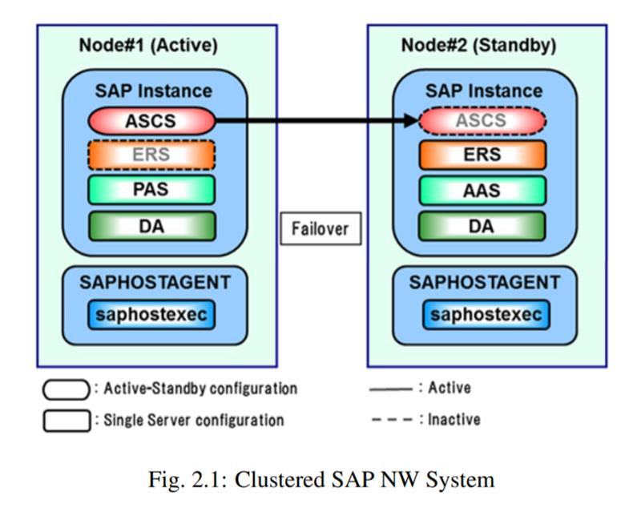

Configuration:
VMware Configuration:
- Both servers are located in individual Esxi host to achieve Host level redundancy.
  - Add affinity rule to keep the VMs running in different host at the Vmware cluster. (refer MYL-UNX-SOP-VMARP- 001)
- Disable DRS automation level to Manual (Refer SOP)
- Snapshot backup need to disable for both the VMs.
- Both VMs should be use individual data store
- Both VMs should have Same amount of CPU and Memory allocation.
- Share storage for cluster mount point should meet following:
  - Eagerly zeroed and independent and persistent disk
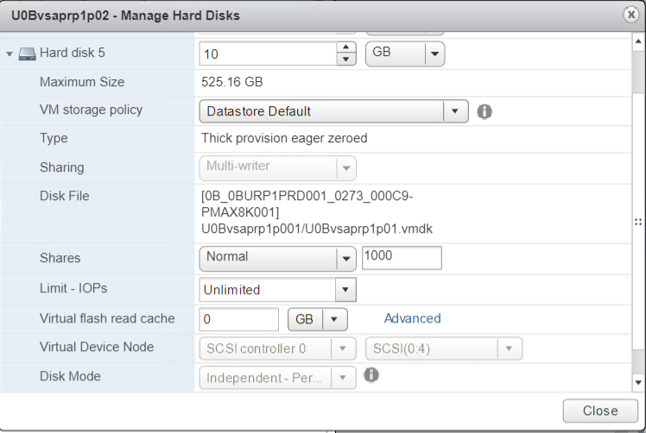
  - Multi-writer sharing mode

- Both the VM should added in the VM folder “Unix RP1-osfence”. So that service account should have access to the VM.
Note: Service account having below privilege:
- System.Anonymous
- System.View
- VirtualMachine.Interact.PowerOff
- VirtualMachine.Interact.PowerOn

OS level Configuration:
- Both server should deploy from Mylan Approved template and required pre-requisites should meet based on the application requirement.
- Both the node configured with required mount points
- Cluster mount point should be created at one server and rescan at another server.
- Disable IPv6 addressing in both server
- Both server should be Subscribe with Redhat enterprise Linux license and resilient storage License, Then enable HA repos mentioned below
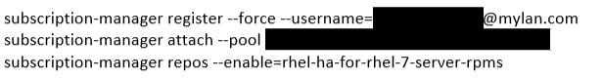
- Install Cluster packages and fencing agents by,
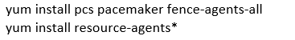
- Reset password of hacluster user in both node with same password and save it in cyper ark password vault.()
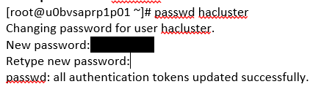
- Make host entry in /etc/host file n both node
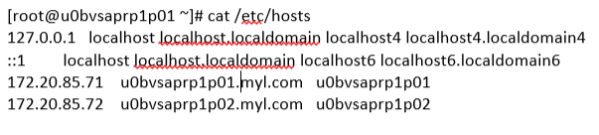
- Make sure that pcs daemon is running on both node from server bootup
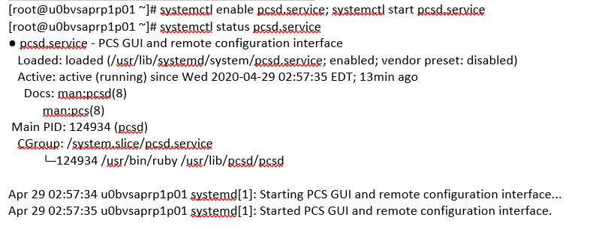
- Authenticate both cluster node in PCS
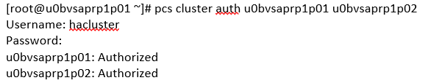
- Create a cluster and populate it with both nodes. Note that the name cannot exceed 15 characters
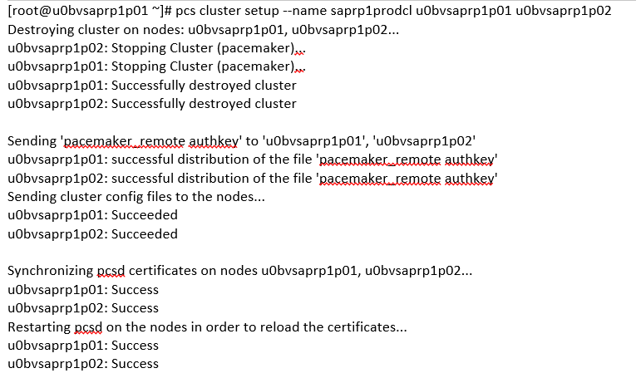
- Start the cluster services in both node now and system bootup.
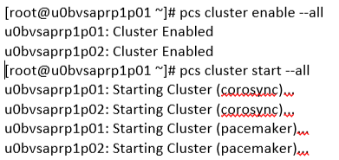
- Validate the cluster Status.
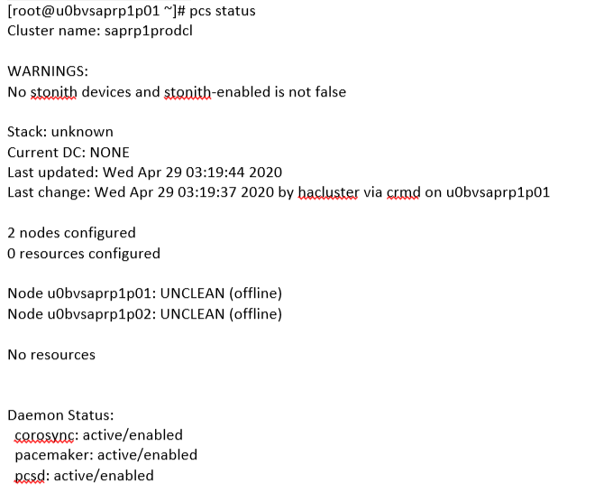
- At this point Cluster was created and resources are not added.
Fencing Configuration:
- Manually verify that the fence agent is able to communicate with the fence device
- Manually fence the Cluster node and validate service account having privilege to fence the node
- Create STONITH Device and add it into the cluster resource by,
- Tuning: (Optional)
  - If stonith device having failure, replace the hostname with IP address of Vcenter
# pcs stonith update fence0_rp1p ipaddr=172.20.21.109
  - If stonith device having Timeout error frequently, Increase the timeout value
# pcs stonith update fence0_rp1p power_wait=5 power_timeout=30 shell_timeout=10 login_timeout=10 retry_on=3
# pcs stonith update fence0_rp1p op monitor timeout=90s

VIP configuration:
- Configure the VIP or Floating IP in Cluster:
  - Floating IP – It should be production or end user communication IP address
  - VLAN of the floating IP was configured at Both Node NIC
  - Better to choose same VLAN as persistent IP
  - Add the IP which needs to be high-available to the cluster,
- Configure the VIP or Floting IP in Cluster:
  - Floating IP – It should be production or end user communication IP address
  - VLAN of the floating IP was configured at Both Node NIC
  - Better to choose same VLAN as persistent IP
Check the Resource status
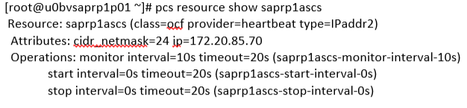
Filesystem Configuration:
Refer attachment for RHEL 8 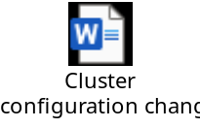
- Create a PV and VG and LV in any one of the node and rescan at another node.

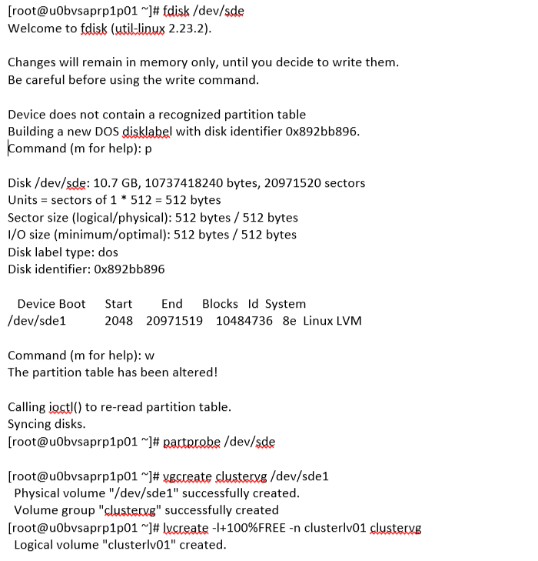
- Modify LVM configuration at both Node:
- Backup the /etc/lvm/lvm.conf file.
- Make sure that “use_lvmetad” parameter is set to “0” in both node. This is mandatory when you use “Pacemaker”.
- To prevent the automatic volume group activation, update the volume_list parameter with local VG’s which needs to be activated automatically.
- Rebuild the “initramfs” boot image to guarantee that the boot image will not try to activate a volume group controlled by the cluster. Update the initramfs device using the following command.
- Reboot the nodes.
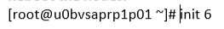
- Configure the VG into Cluster by
- Check the resource status:
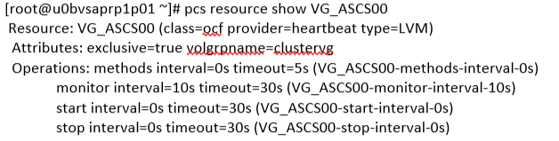
- Configure FS into Cluster by,
- Check the resource status:
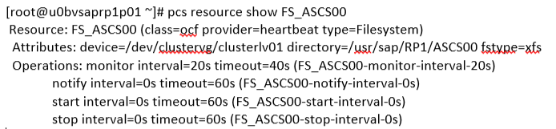
Application Configuration:
- Once Infra ready, handover the cluster setup to basis team to configure Application service on both Node.
Configure Application startup and start script in Cluster:
- SAP will provide application start, stop and validation command to configure it in cluster.
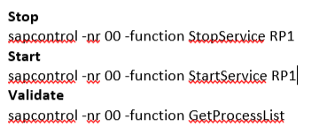
- Create start and stop script from given Application command
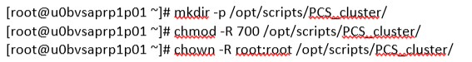
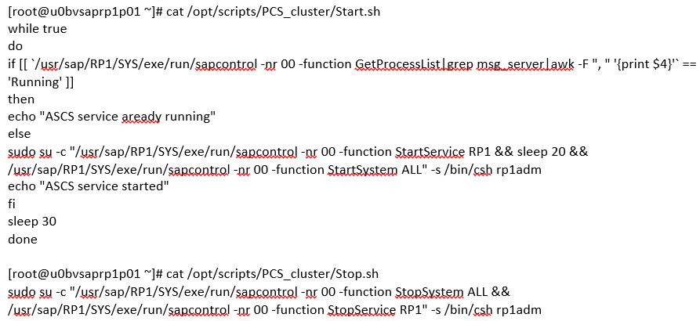
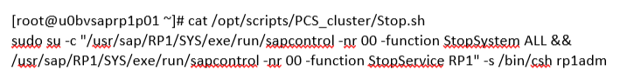
- Create the Application service at OS level with stop and start script and reload systemctl daemon

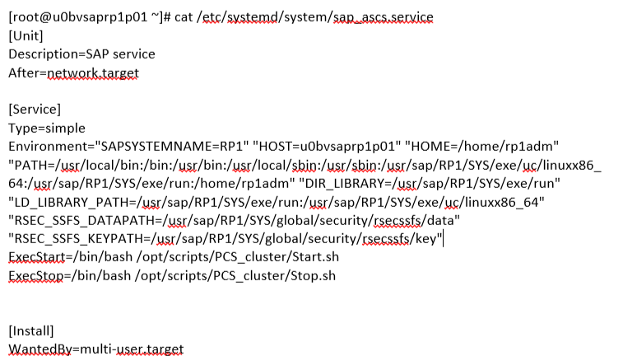
- Test application service at OS level.

- Add the application service in Cluster

Resource constraint configuration:
- Configure order and colocation constraint for cluster resources based on sequential.
  - saprp1ascs
  - VG_ASCS00
  - FS_ASCS00
  - ASCS_RP1
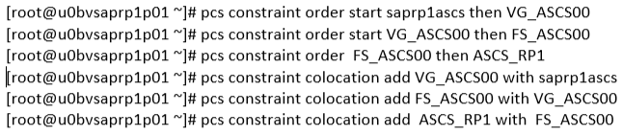
To check the constraint status,
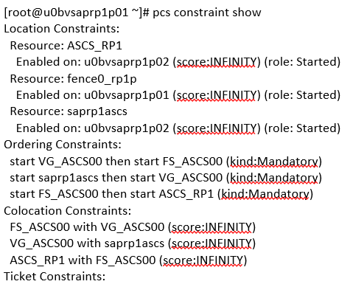
Check the cluster status
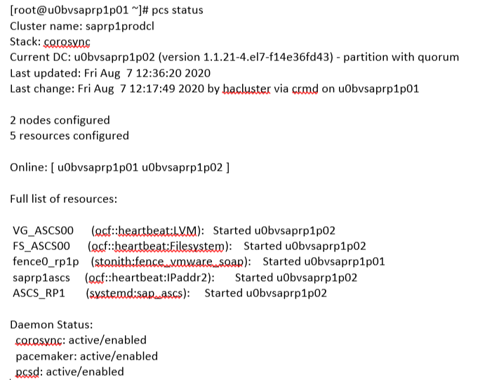
Alert Configuration:
Configure the cluster alert to Zenoss Monitoring SMTP probe By,

# install --mode=0755 /usr/share/pacemaker/alerts/alert_smtp.sh.sample /var/lib/pacemaker/alert_smtp.sh
# pcs alert create id=smtp_alert path=/var/lib/pacemaker/alert_smtp.sh options email_sender=cluster_sapgepclst@myl.com
# pcs alert recipient add smtp_alert =netcoolemailmonitoring_dev@myl.onmicrosoft.com

